MZL350I-PI-EXT LCD DISPLAY MODULE

Table of Contents

1. Intro ........................................................................................................... 2
2. Features ................................................................................................... 2
3. Pins’ Definition ............................................................................................ 3
4. Module Structure .......................................................................................... 4
5. Quick Start ................................................................................................... 5
6. Appendix ...................................................................................................... 6

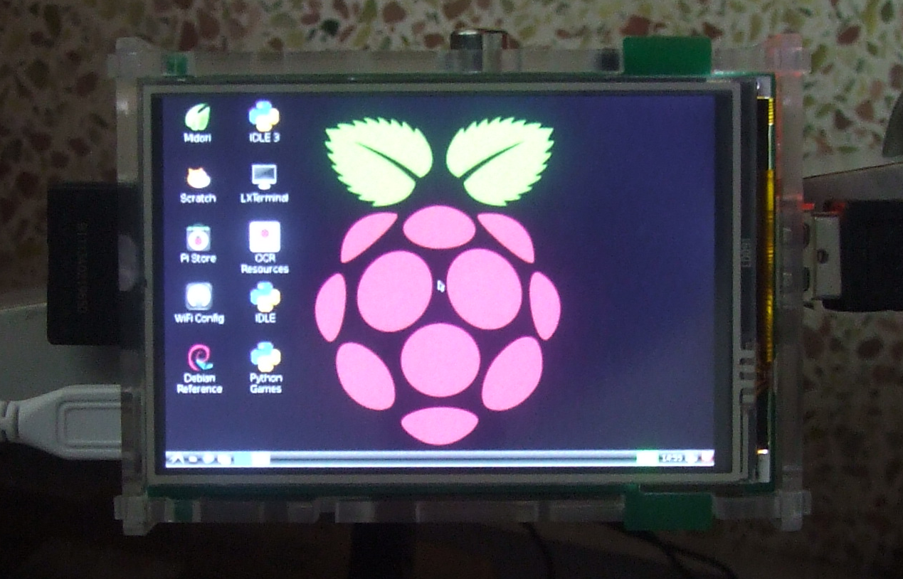

1. Intro
The MZL350I-PI-EXT touch screen module is an expansion board tailored specifically for the raspberry pi (RPi). It is an inexpensive display module by using the GPIO on the P1 connector, the SPI connector as data transmit medium. The CPLD on the display module controls display info according to the data transmitted from the SPI connector.

Specifies：
-  Easy to set and use
-  480x320 pixels，16bit，65k colors
-  3.5 inch resistive touch screen
-  The LCD transmits data through SPI (Serial Peripheral Interface)，the SPI has a maximum clock speed at 125MHZ
-  The touch screen transmits data through SPI (Serial Peripheral Interface)，the SPI has a maximum clock speed at 16MHZ
-  No external power supply needed
-  The module includes a On/Off switch（Brought Extra）, and a EEPROM storage unit
-  Open source Linux driver used

2. Features
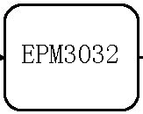
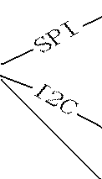
LCD Display

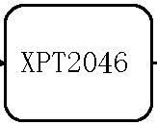
RPi
Touch Panel
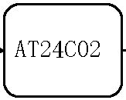

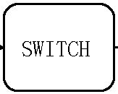

MZL350I-PI-EXT显示扩展板包含一颗高速CPLD芯片（EPM3032），SPI接口的4线电阻式触摸控制芯片（XPT2046），I2C接口的EEPROM存储器（AT24C02）。
其中的I2C接口芯片（AT24C02）的地址为：0xA0

3. 引脚定义

RPi “P1” Connector |  | MZL350I-PI-EXT
 | 3V3 Power
 | 5V Power
 | GPIO-0(IIC SDA) | AT24C02 SDA (Data Pin)
 | 5V Power
 | GPIO-1(IIC SCL) | AT24C02 SCL (Clock Pin)
 | GND
 | GPIO-4 | XPT2046 IRQ
 | GPIO-14
 | GND
 | GPIO-15 | LCD RST (Screen Reset)
 | GPIO-17
 | GPIO-18(PWM) | LCD PWM (Backlight Brightness Control)
 | GPIO-21
 | GND
 | GPIO-22 | SWITCH (On/Off)
 | GPIO-23
 | 3V3 Power
 | GPIO-24
 | GPIO-10 (SPI MOSI) | LCD/TP MOSI
 | GND
 | GPIO-9 (SPI MISO) | LCD/TP MISO
 | GPIO-25 | LCD RS
 | GPIO-11 (SPI SCLK) | LCD/TP SCLK SPI
 | GPIO-8 (SPI CE0) | LCD Chip Select
 | GND
 | GPIO-7 (SPI CE1) | Touch Panel Chip Select

4. Module Structure

MZL350I-PI-EXT LCD Display Module Dimensional Drawing:

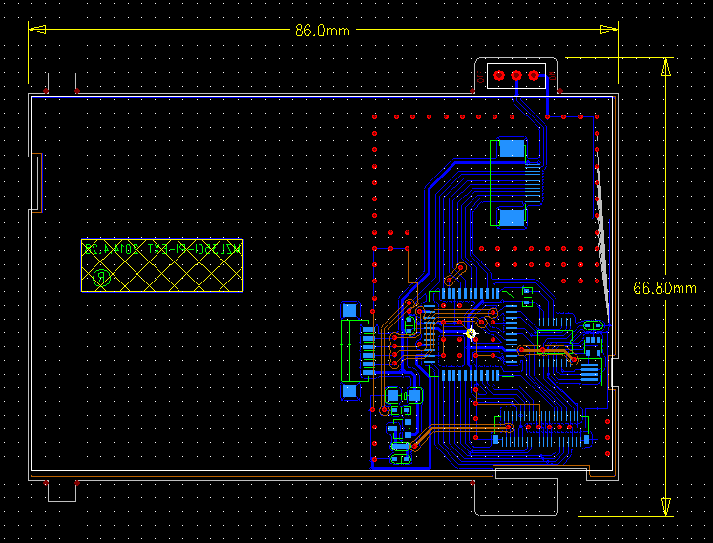

5. Quick Start

For first time use, follow the following steps:
1 Take the display driver zip file（mzl350i-pi-ext.rar）and copy it to target RPi through SD card reader or through SSH, then extract the files under /home/pi.

2 Make changes to config.txt
Go into the “boot” index, use nano editing tool to edit config.txt, enter the commends:
sudo nano config.txt
next, find the lines
# uncomment to force a console size. By default it will be display's size minus
# overscan.
Change #framebuffer_width=1280
#framebuffer_height=720
these two lines to:
#framebuffer_width=960
#framebuffer_height=640

3 Go into the extracted file index，enter the commend:
cd /home/pi/mzl350i-pi-ext/src
To recompile：enter commend：make

4 Copy the self start footer file “lcd” under “/etc/init.d” and enter commend:
sudo cp lcd /etc/init.d

5 Next set the system to load lcd driver everytime upon startup, go into “/etc/init.d”, and enter commend:
sudo update-rc.d lcd defaults

6 Reboot the system, enter commend:
sudo reboot

6. Appendix

Display controller handbook : ili9481.pdf
Touch panel controller handbook : xpt2046.pdf
EEPROM storage unit handbook : at24c02.pdf

